**IR Senor**

**Description**

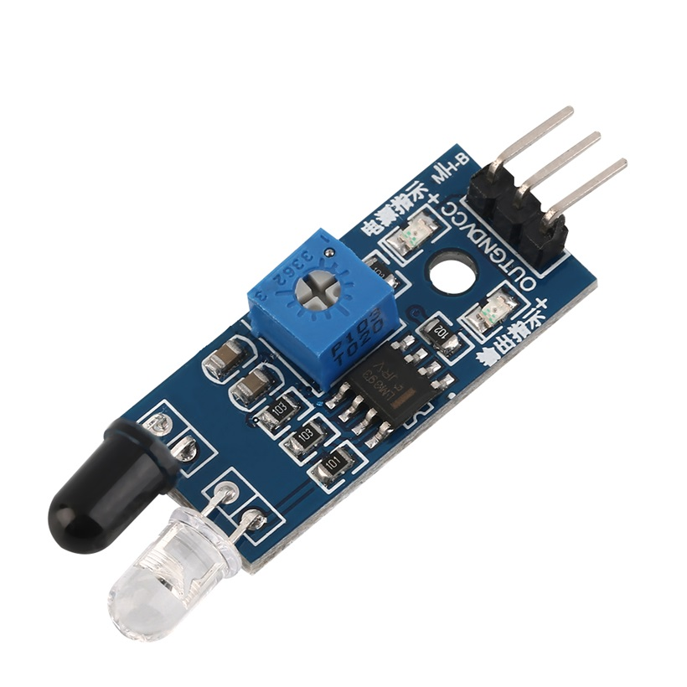

**1. Details:**

**An Infrared (IR) sensor is an electronic device that detects infrared radiation, which is emitted by all objects as a form of heat. IR sensors are used to detect objects, measure temperature, or sense motion without physical contact.**

**2. How IR sensors work:**

**The working principle of an IR sensor depends on its type, but typically involves two main components:**

**Emitter: An infrared LED that sends out infrared light.**

**Detector: An infrared-sensitive photodiode or phototransistor that detects the IR light.**

**In active sensors, the emitter sends out a signal that reflects off an object and returns to the detector. The detector then converts this light into an electrical signal. In passive sensors, the detector simply reads the infrared radiation given off by objects in its field of view.**

**3. Pin Configuration :**

* **Pin Name: VCC**

**Description: Power Supply Input (e.g., 5V or 3.3V)**

**---**

* **Pin Name: GND**

**Description: Ground**

**---**

* **Pin Name: OUT**

**Description: Digital Output (LOW when an obstacle is detected)**

**4. Test Code:**

// Define the pin where the IR sensor's OUT pin is connected

const int irSensorPin = 7;

void setup() {

// Initialize serial communication at 9600 bits per second

Serial.begin(9600);

// Set the IR sensor pin as an input

pinMode(irSensorPin, INPUT);

Serial.println("IR Sensor Test Starting");

}

void loop() {

// Read the state of the IR sensor pin

int sensorValue = digitalRead(irSensorPin);

// Check if an obstacle is detected.

// Note: Some IR sensor modules are "active low," meaning the output is LOW when an obstacle is detected.

if (sensorValue == LOW) {

Serial.println("Obstacle detected!");

} else {

Serial.println("Path is clear.");

}

// Wait a moment before the next reading to avoid rapid output

delay(200);

}

